Name: | David Daniels
UID: | 2023300038
Experiment No. | 2B

AIM: | Constructor Overloading
Program 1
PROBLEM STATEMENT : | A program to simulate a simple banking system in which the initial balance and rate of interest are read from the keyboard and these values are initialised using the constructor member function. The program consists of the following methods:  To initialise the balance amount and the rate of interest using constructor member function  To make deposit  To withdraw an amount  To find compound interest based on the rate of interest  To know the balance amount  To display the menu options  Note:  Balance cannot be less than 0.  In a Saving account if minBalance is set then for that the balance cannot go less than that amount. If it goes, an error must be shown.  You can set the values by default for the above variables in Checking Account class
PROGRAM: | import java.util.*;  class calc  {  private double bal;  private double inter;  private double min_bal;  Scanner sc1 = new Scanner (System.in);  //savings acc  calc(double a , double b )  {  if(a>0)  {  this.bal = a;  this.min_bal =200;  this.inter = 2.5;  }  else  {  System.out.println("balance must be more than 0 or rate of interest cant be 0 for a savings account");  }  }  void sav_menu()  {  System.out.println("press 1 to make a deposit \n press 2 to withdraw money \n press 3 to find interest after 1 year \n press 4 to find out your current balance \n press 5 to quit");  int a = sc1.nextInt();  switch (a)  {  case 1:  {  deposit();  break;  }  case 2:  {  withdraw_sav();  break;  }  case 3:  {  find_int();  break;  }  case 4:  {  print_bal();  break;  }  case 5:  {  System.exit(0);  break;  }  default:  {  System.out.println("Enter a number between 1 and 5 ._.");  break;  }  }  }  void withdraw_sav()  {  System.out.println("How much money do you want to withdraw");  double width_sav = sc1.nextDouble();  if(bal-width_sav>0 && bal-width_sav>min_bal)  {  bal-=width_sav;  print_bal();  }  else  {  System.out.println("You do not have enough money to widhdraw or you will go below minimum allowed balance ");  }  }  void find_int()  {  bal = bal*(1+(inter*0.01));  print_bal();  }  //current acc  calc(double a)  {  this.bal =a;  }  void cur_menu()  {  System.out.println("press 1 to make a deposit \n press 2 to withdraw money \n press 3 to find out your current balance \n press 4 to exit ");  int a = sc1.nextInt();  switch (a)  {  case 1:  {  deposit();  break;  }  case 2:  {  withdraw_cur();  break;  }  case 3:  {  print_bal();  break;  }  case 4:  {  System.exit(0);  break;  }  default:  {  System.out.println("Enter a number between 1 and 4 ._.");  break;  }  }  }  void deposit()  {  System.out.println("How much money do you want to deposit");  double dep = sc1.nextDouble();  bal+= dep;  print_bal();  }  void print_bal()  {  System.out.println("your balance is: "+bal);  }  void withdraw_cur()  {  System.out.println("How much money do you want to withdraw");  double width_cur = sc1.nextDouble();  if(bal-width_cur>0)  {  bal-=width_cur;  print_bal();  }  else  {  System.out.println("You do not have enough money to widhdraw");  }  }  }  public class bank  {  public static void main (String args[])  {  Scanner sc = new Scanner (System.in);  System.out.println("Enter 1 for savings aaccount \n enter 2 for current account");  int a = sc.nextInt();  switch (a)  {  case 1:  {  System.out.println("Enter initial balance");  double q = sc.nextDouble();  calc c1 = new calc(q,0);  c1.sav_menu();  break;  }  case 2:  {  System.out.println("Enter initial balance");  double p = sc.nextDouble();  calc c1 = new calc(p);  c1.cur_menu();  break;  }  default:  {  System.out.println("Enter a number between 1 and 2 ._. ");  }  }  }  }
RESULT: 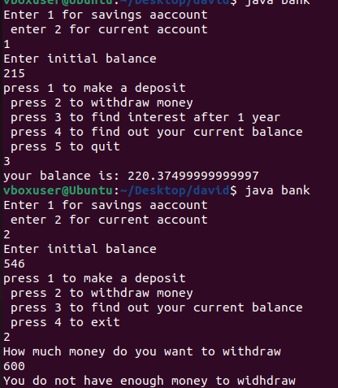

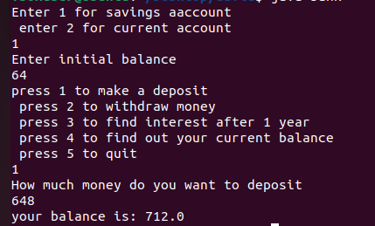
Program 2
PROBLEM STATEMENT : | Write a menu driven program to recruit an employee (depending on his performance in various rounds) in some software company using constructor overloading.  Selection Criteria for each post is given below:  Programmer(Minimum total of 80 marks ):-  Rounds:-  Course Work  Aptitude Test  Technical Test  Interview  Team Leader(Minimum total of 85 marks ):-  Rounds:-  Technical Test  Interview  Project Manager(Minimum score 90 marks)  Rounds:-  Interview  Create a class Posting and write 3 constructors to initialize the object and set the parameters and display the employee post according to selection criteria.  Data members:  private int courseWork;  private int AptTest;  private int TechTest;  private int interview;  Methods:  public Posting(int courseWork, int AptTest, int TechTest,int interview)  public Posting(int TechTest,int interview)  public Posting(int interview)  Make use of ‘this’ keyword. Create arrray of objects , give the list of candidates selected for each post(Programmer, Team Lead and project Manager)
PROGRAM: | import java.util.*;  class posting  {  private int apt;  private int course;  private int tech;  private int inter;  private int tot=0;  //programmer  posting(int a , int b , int c , int d)  {  this.apt = b;  this.course = a;  this.tech = c;  this.inter =d;  }  //team lead  posting (int p , int q)  {  this.tech = p;  this.inter =q;  }  //manager  posting (int x)  {  this.inter =x;  }  void progra()  {  tot = apt + course + tech + inter;  if (tot>=80)  {  System.out.println("You are hired as programmer :) ");  }  else  {  System.out.println("You are not hired :( ");  }  }  void lead()  {  tot = tech + inter;  if (tot>=85)  {  System.out.println("You are hired as team lead :) ");  }  else  {  System.out.println("You are not hired :( ");  }  }  void manag()  {  tot = inter;  if (tot>=90)  {  System.out.println("You are hired as manager :) ");  }  else  {  System.out.println("You are not hired :( ");  }  }  }  public class hire  {  public static void main (String args[])  {  Scanner sc = new Scanner (System.in);  System.out.println("Which position are you applying for");  System.out.println("Enter 1 to check for programmer \nEnter 2 to check for team lead \nEnter 3 to check for project manager: ");  int a = sc.nextInt();  switch(a)  {  case 1:  {  System.out.println("Enter coursework marks");  int cou = sc.nextInt();  System.out.println("Enter aptitude test marks");  int apt = sc.nextInt();  System.out.println("Enter technical test marks");  int t = sc.nextInt();  System.out.println("Enter interview marks");  int inter = sc.nextInt();  posting c1 = new posting(cou,apt,t,inter);  c1.progra();  break;  }  case 2:  {  System.out.println("Enter technical test marks");  int t = sc.nextInt();  System.out.println("Enter interview marks");  int inter = sc.nextInt();  posting c1 = new posting(t,inter);  c1.lead();  break;  }  case 3:  {  System.out.println("Enter interview marks");  int inter = sc.nextInt();  posting c1 = new posting(inter);  c1.manag();  break;  }  default:  {  System.out.println("ENTER A NUMBER BETWEEN 1 AND 3 ._. you are fired");  }  sc.close();  }  }  }
RESULT: 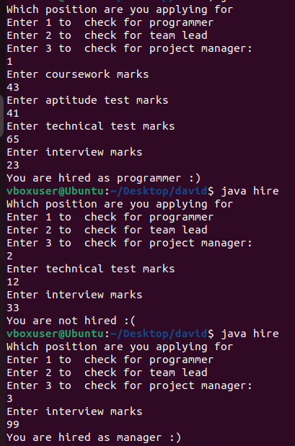
CONCLUSION: | Thus we have learned how to overload constructors in java

